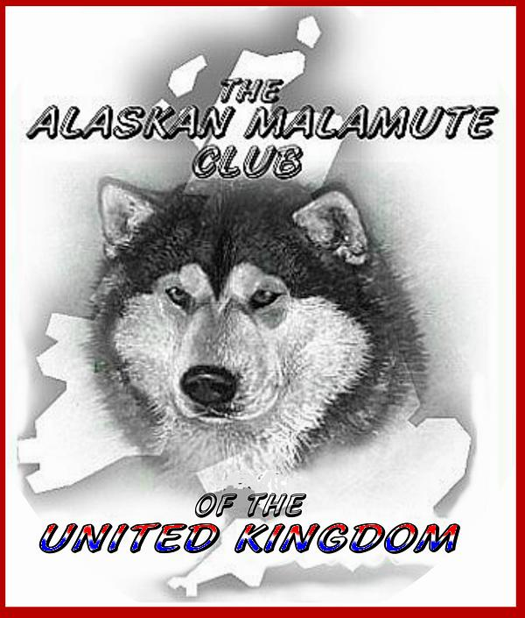

and
Hands-On Assessment

Sunday 22nd July 2018
To be held in
Shenstone Village Hall, Barnes Road, Shenstone, Lichfield, Staffs. WS14 0LT

Booking Form
(Please use a separate form for each person)

Name Mr/Mrs/Miss/Ms (Please Delete)

Address

Postcode_________________

Phone_____________________ Mobile

Email:

Members (Seminar including lunch) £20.00............................
Hands-on breed assessment £ 5.00............................
Total £.....................................

Non-Members (Seminar including lunch) £25.00.............................
Hands-on Breed assessment £ 8.00.............................
Total £………..……......................

If you require a vegetarian lunch please tick

After the assessment of the dogs in the “Hands On” candidates will write up their findings, which will then be considered by the panel anonymously.

If you would prefer an interview please tick here

Please send completed booking form and cheque made payable to A.M.C.U.K to:
Mrs Anne Nevinson, 51 Holyoake Terrace, Ulverston, Cumbria. LA12 9DD.
Tel: 01229 583053. email:anne@wintalakes.org.uk

